Laxmi Charitable Trust’s
Sheth L.U.J College of Arts & Sir M.V. College of Science and Commerce
Department of Information Technology (B.Sc.I.T Semester V)
Data Visualization with Power BI and Tableau
Practical – VIII
Roll No.:T023 | Name: Som Mishra
Class: TYIT | Batch:1
Date of Assignment:27-8-2026 | Date/Time of Submission:27-8-2026

Part B – Program
Performing Advanced Analytics using Trends, Clustering, and Forecasting
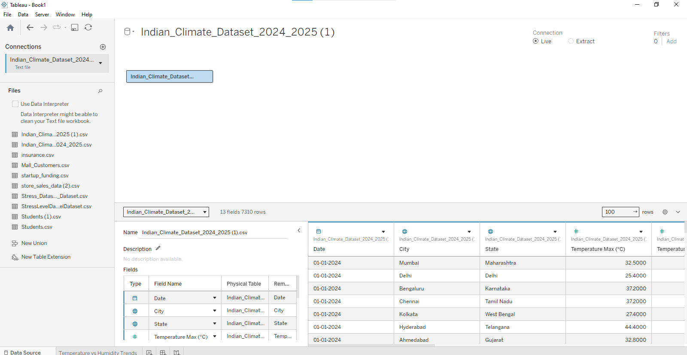
- Add and interpret trend lines (linear, exponential)
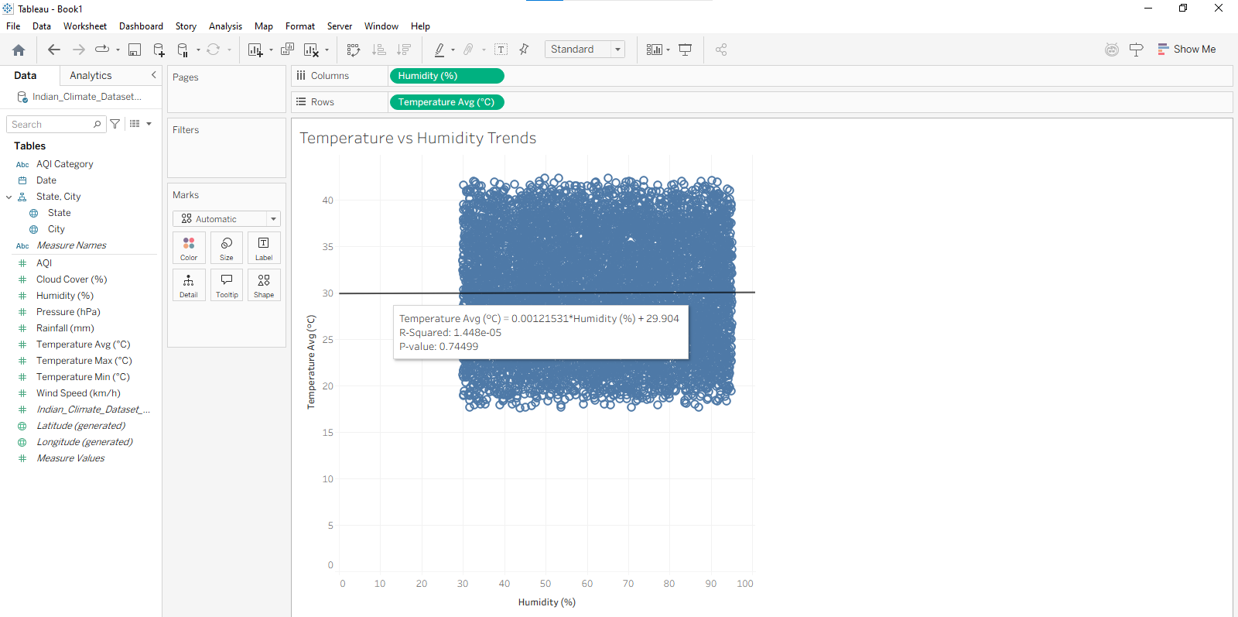
- Customize and analyze trend models
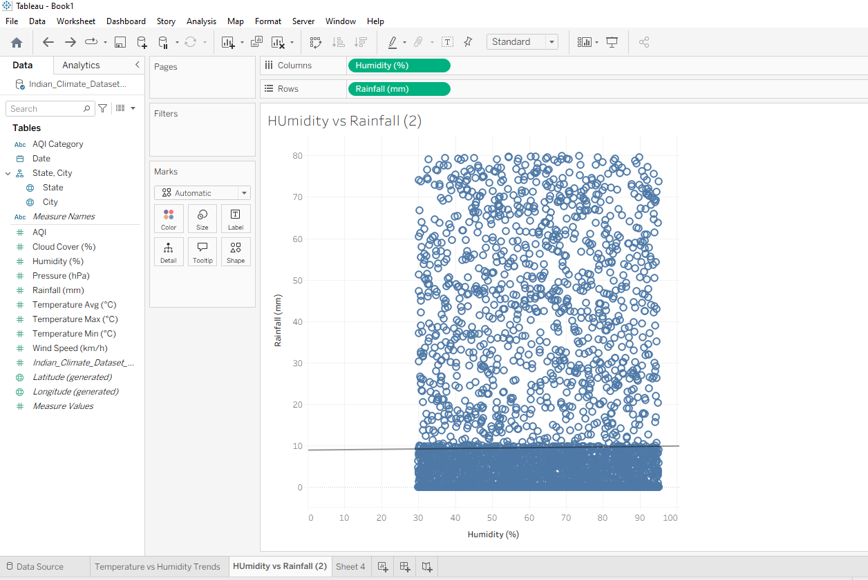

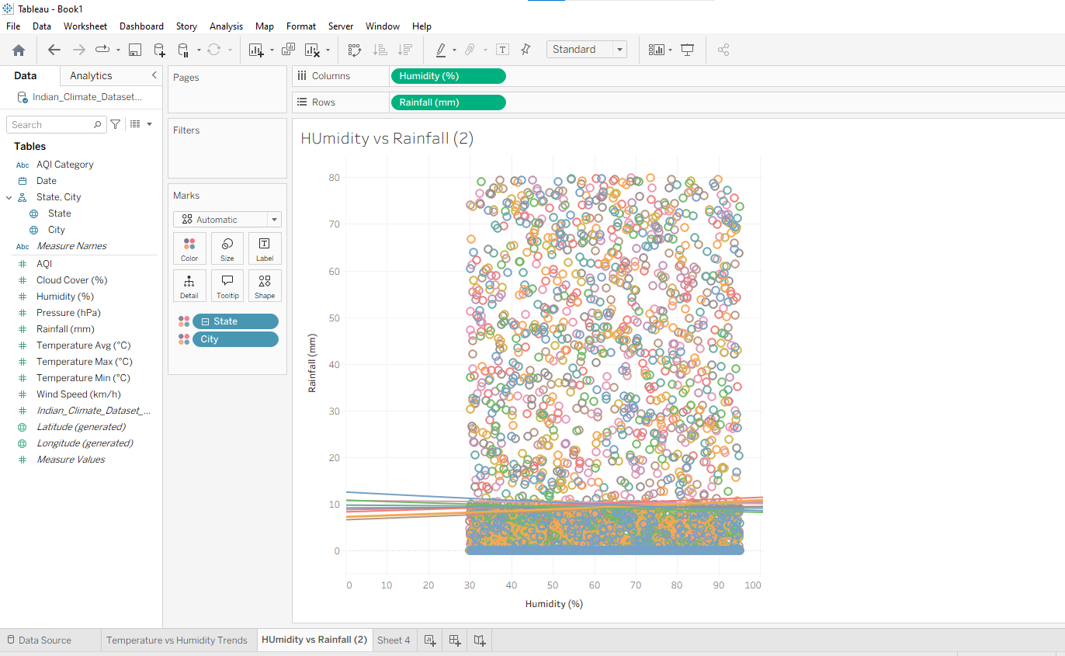

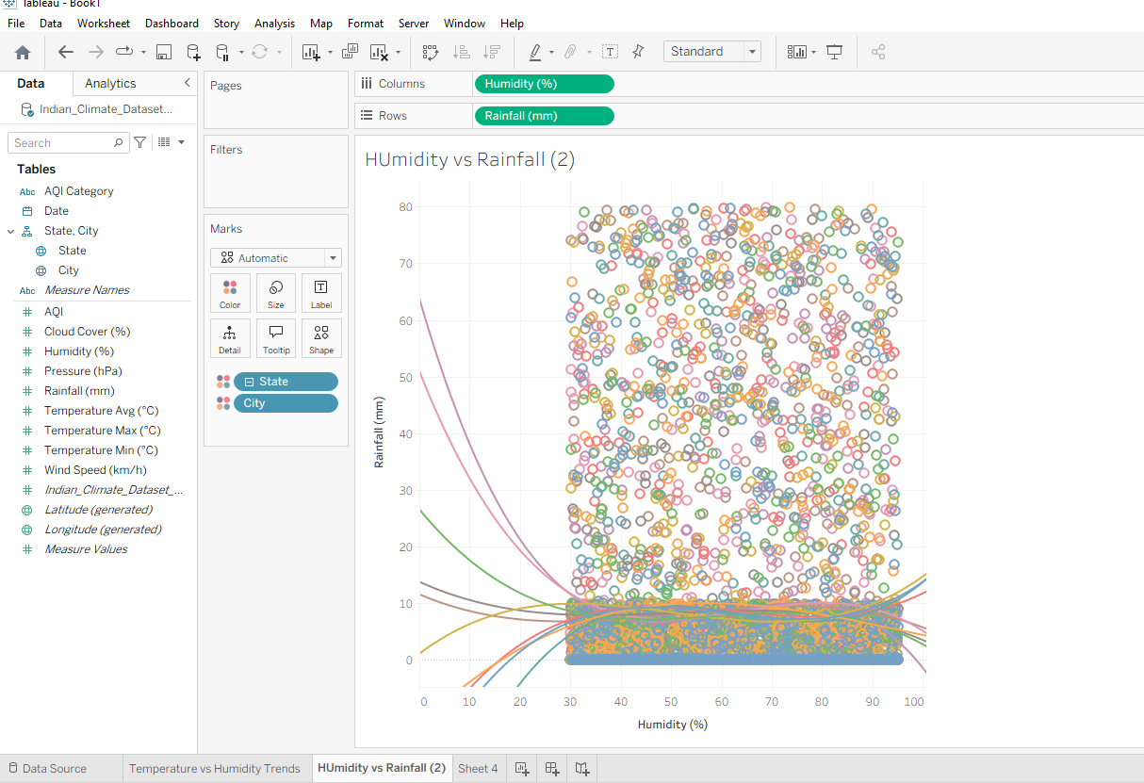
- Perform clustering on datasets
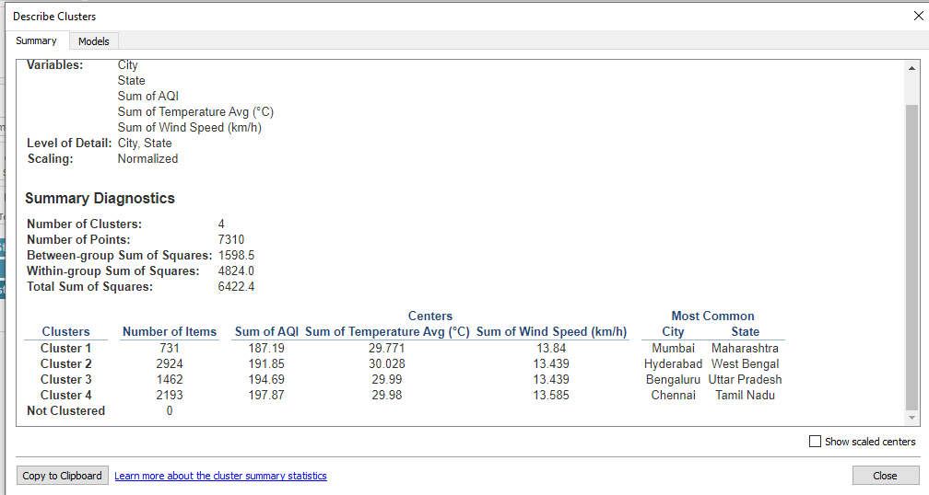
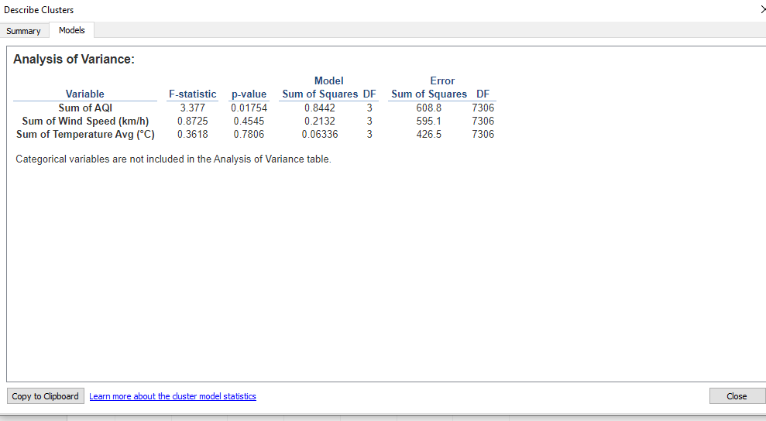

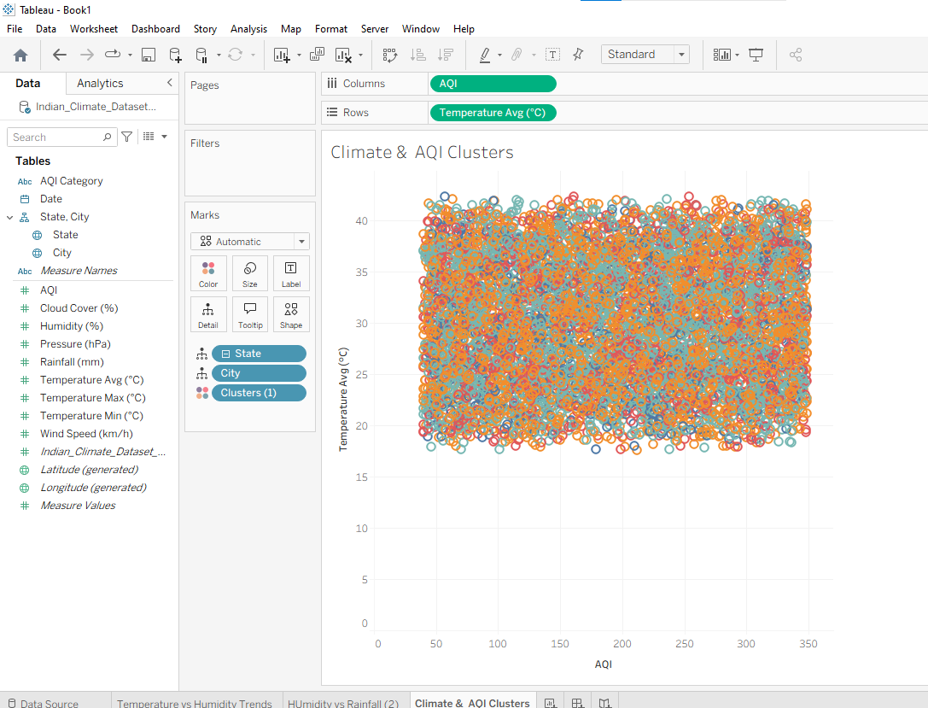
- Analyze distributions using built-in tools
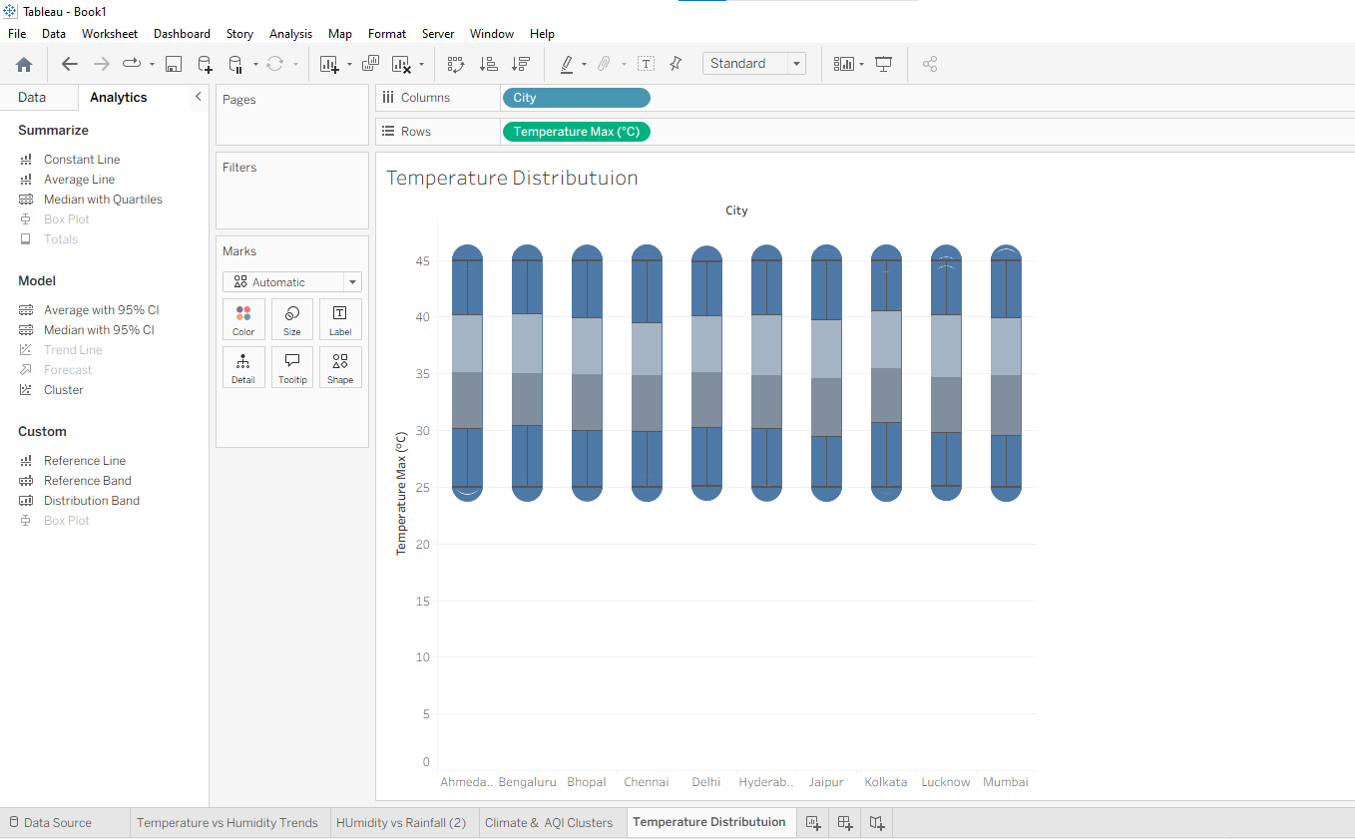
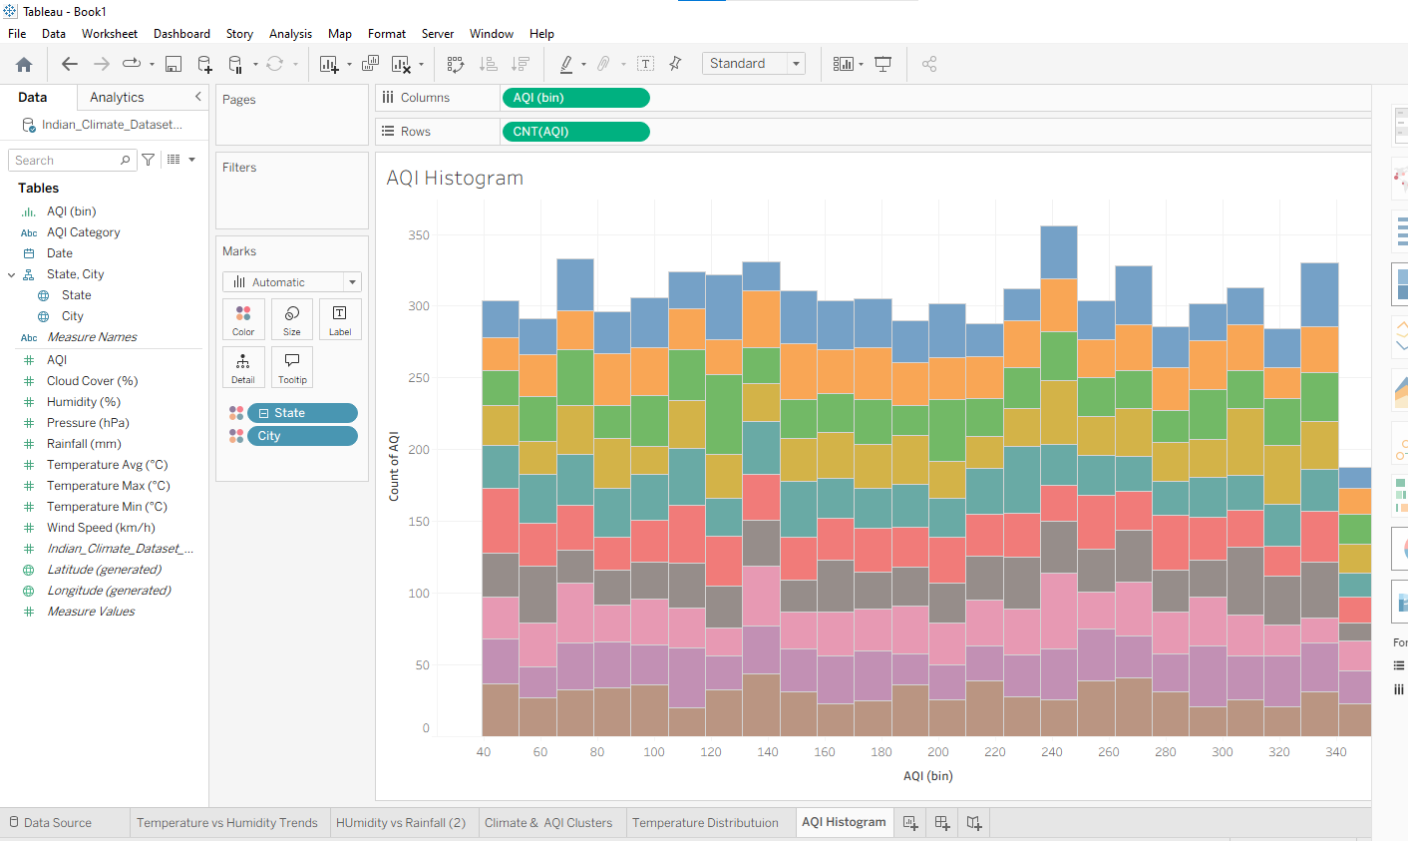
- Apply forecasting techniques
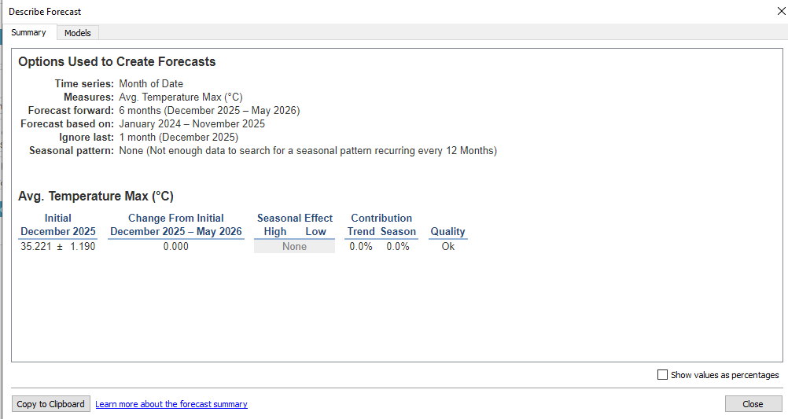
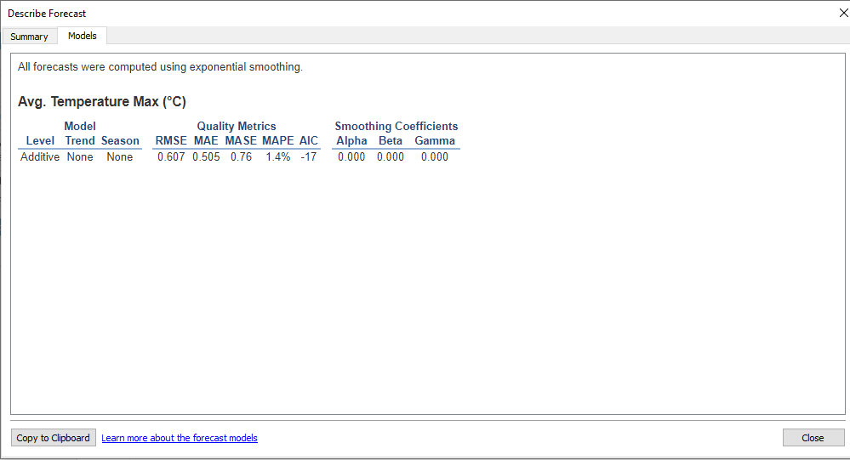
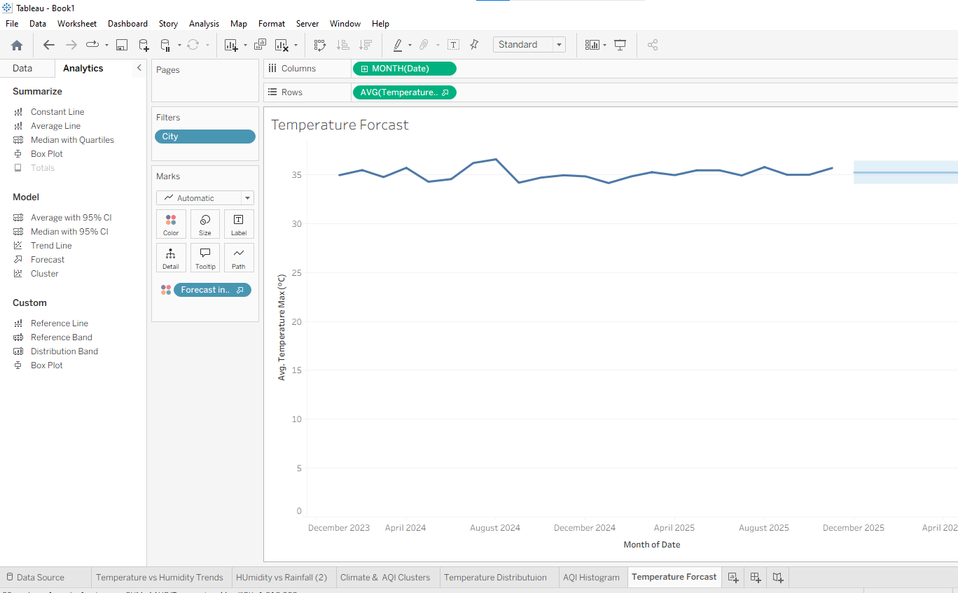
- Compare different statistical models
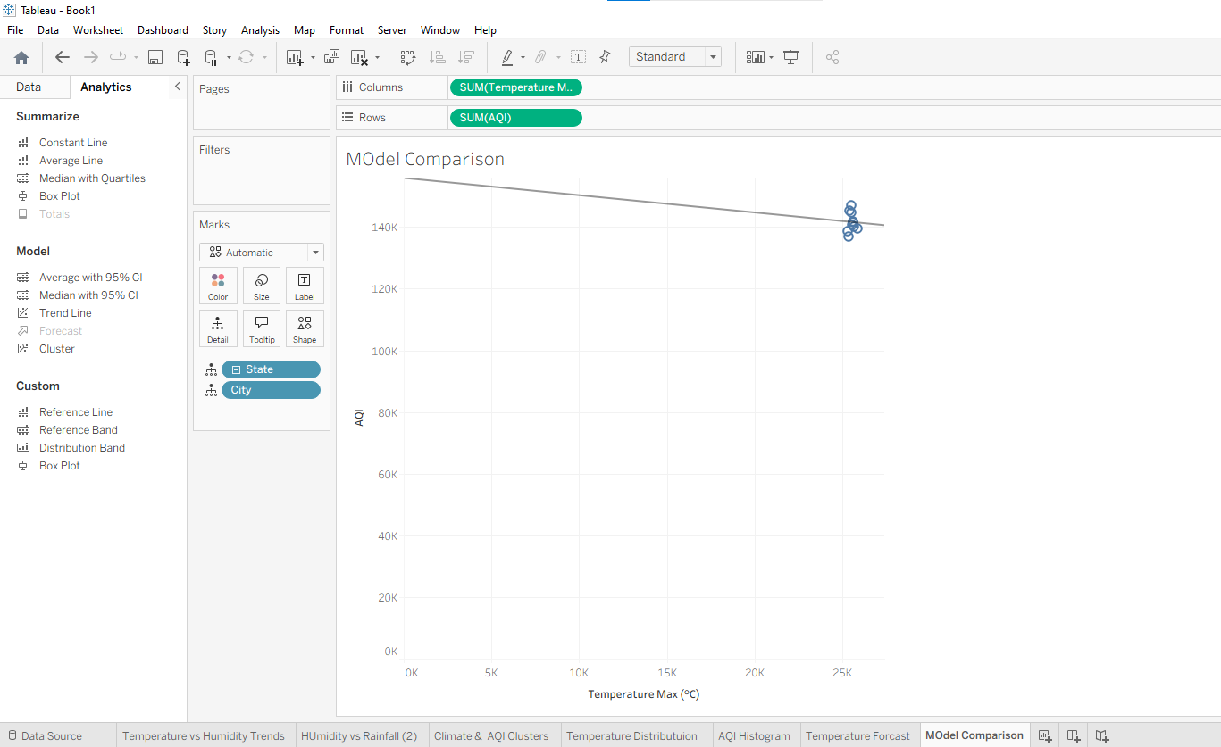

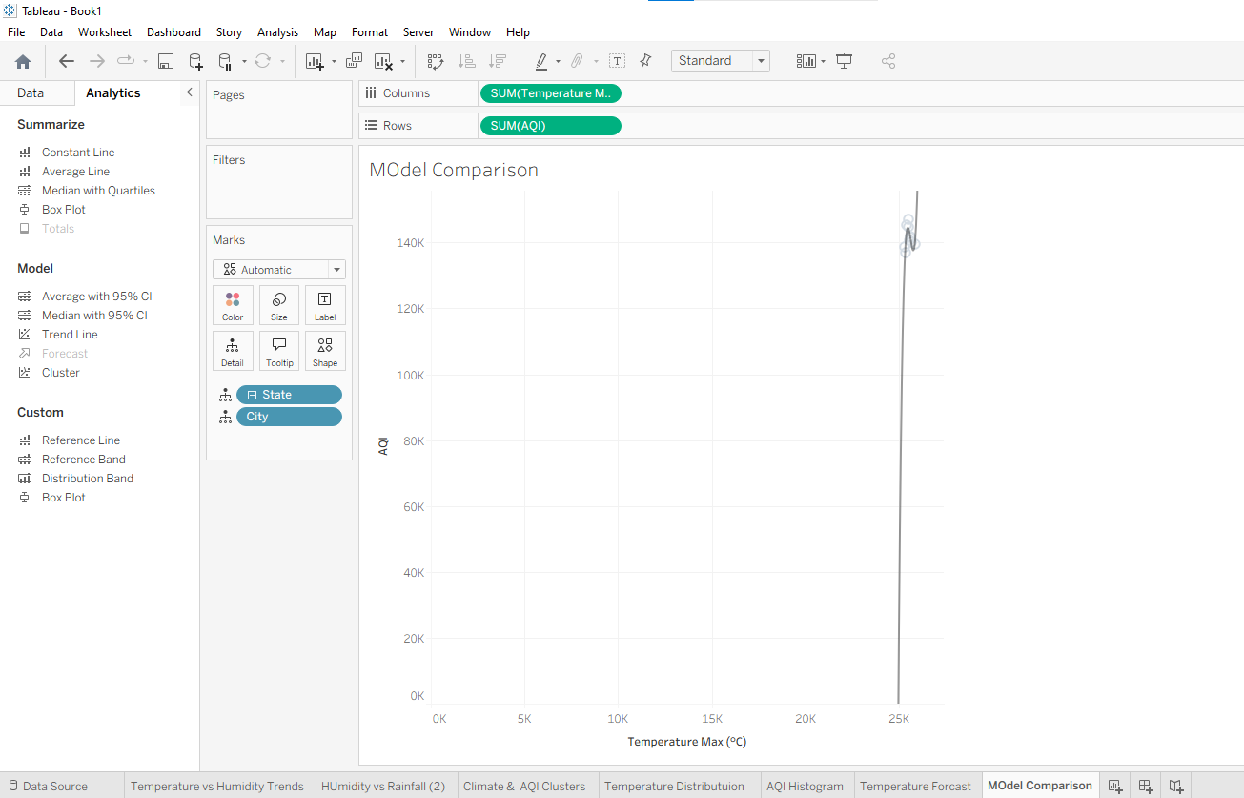
g) Export and interpret statistical results

